**Khanh Q.Bach-Optimization modeling of the smartphone supply chain**

In this project, a transshipment optimization model is built using Excel solver where three types of goods are transported from three factories to five retailers with four warehouses playing the role of intermediaries. In the model, the decision variables are the quantities of all three products being transported via are different routes. Moreover, there are three main types of transporting route including routes from factories to warehouses, factories to retailers and warehouses to retailers. The purpose of this model is to minimize the cost of delivering products from factories to retailers by determining the decision variables which are optimal numbers of goods allocated to each of the transportation routes. *Figure 1* explains the components of the equations which will be given in the next part.

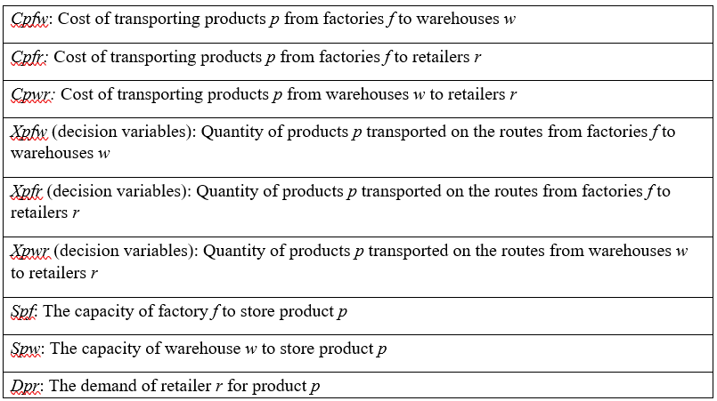*Figure 1: Components in the mathematical equations*

Initially, the objective function which is the total cost of transportation is calculated as follow:

$$Total cost=\sum_{p=1}^{3}{\sum_{f=1}^{3}{\sum_{w=1}^{4}{Cpfw*Xpfw}+}}\sum_{p=1}^{3}{\sum_{f=1}^{3}{\sum_{r=1}^{5}{Cpfr*Xpfr+}}}\sum_{p=1}^{3}{\sum_{w=1}^{4}{\sum_{r=1}^{5}{Cpwr*Xpwr}}}$$

Additionally, constraint is also an inevitable factor in an optimization model; hence, four major constraints in this case are formulated:

* **Factory capacity**: The total quantities of a particular product transported from factories to all warehouses and retailers need to be less than or equal to the factories’ capacity to store that type of product.

$$Spf≥\sum_{w=1}^{4}{Xpfw+}\sum_{r=1}^{5}{Xpfr} (p=1,2,3;f=1,2,3)$$

For example, with *p*=1 and *f*=1, the equation is interpreted as the total number of product 1 transported from factory 1 to all four warehouses and five retailers is less than or equal to the factory 1’s capacity to store product 1. After adopting all of the values of *p* and *f*, the factory capacity constraint is demonstrated in *figure 2*.

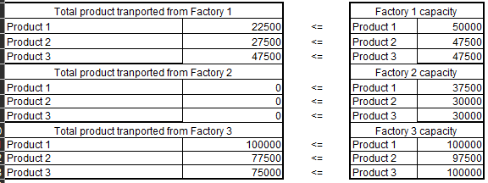

*Figure 2: Factory capacity constraint*

* **Warehouse capacity**: The total quantities of a particular product transported from factories to warehouses need to be less than or equal to warehouses’ capacity to store that type of product.

$$Spw≥\sum_{f=1}^{3}{Xpfw (p=1,2,3;w=1,2,3,4)}$$

For instance, if *p=*1 and *w=*3, the equation is interpreted as the total number of product 1 transported from all three factories to warehouse 3 need to be less than or equal to the warehouse 3’s capacity to store product 1. After adopting all of the values of *p* and *w*, the warehouse capacity constraint is demonstrated in *figure 3*.



*Figure 3: Warehouse capacity* *constraint*

* **Retailer demand**: The total quantities of a particular product received by retailers need to be equal to the retailers’ demand for that type of goods. In some cases, this figure could also be set as greater than or equal to the demand to generate an ideal result. However, it would not be the optimal outcome in practical scenario due to the law of supply and demand. In detail, if the number of goods delivered to retailers is too much higher than their demand, the sell price of the goods will be reduced damaging the overall profit of the organization (Otero, 2022). Thus, the retailer demand constraint in this case is calculated as follow:

$$Dpr=\sum_{f=1}^{3}{Xpfr+ \sum_{w=1}^{4}{Xpwr} (p=1,2,3;r=1,2,3,4,5)}$$

In explanation, if *p*=2 and *r=*5, for example, the equation indicates that the total quantities of product 2 delivered to retailer 5 from all of three factories and four warehouses is equal to the retailer 5’s demand for product 2. After adopting all of the values of *p* and *r*, the retailer demand constraint is demonstrated in *figure 4*.

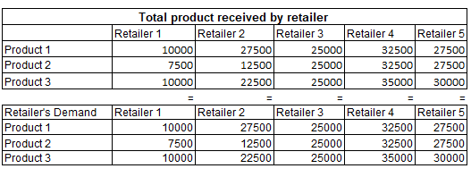

*Figure 4: Retailer demand constraint*

* **Equivalent between number of product transport from factories to warehouses and from warehouses to retailers**: The total quantities of a particular product deliver in 2 main routes, factories to warehouses and warehouses to retailers, need to be equal.

$$\sum_{f=1}^{3}{Xpfw}=\sum_{r=1}^{5}{Xpwr (p=1,2,3;w=1,2,3,4) }$$

To clarify the equation, values of *p=*2 and *w=*2 are taken as an example. In this case, the total quantities of product 2 delivered to warehouse 2 from all three factories is equal to the total numbers of product 2 transported from warehouse 2 to all five retailers. After adopting all of the values of *p* and *w*, this constraint is demonstrated in *figure 5.*

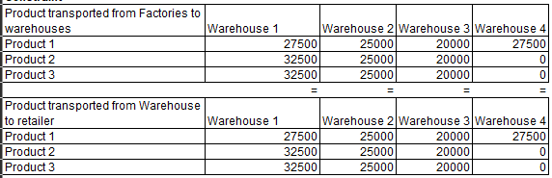

*Figure 5: Product received by warehouses and transported from warehouses*

After the optimization problem is solve using excel solver, the final optimized transportation cost is $1,179,375 along with total costs for each of the main routes are shown in *figure 6*.

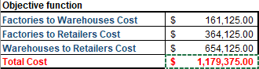

*Figure 6: Optimized results*

In order to obtain the final outcome in *figure 6*, the products allocation via main routes are explained in *figure 7*, *figure 8* and *figure 9*. In general, transshipment routes in which products are delivered to the warehouses before being received by retailers are more optimal than the direct shipments from factories to retailers which are relatively costly. This results from the fact that although only small quantities of goods are allocated to direct routes from factories to retailers (*figure 8*), the transportation cost produced from these routes is still relatively high at $364,125 accounting for one third of the total cost (*figure 6*). Therefore, all three types of products are transported from factories to warehouses before being distributed to the retailers for optimal outcome.

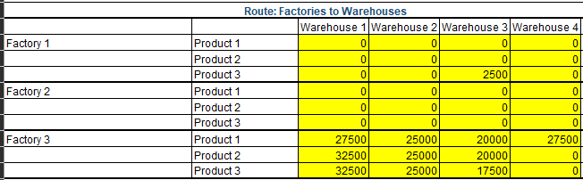

*Figure 7: Product allocated via routes from factories to warehouses*

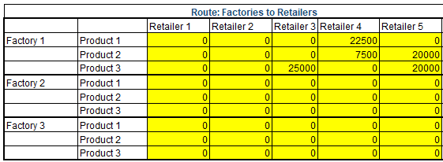

*Figure 8: Product allocated via routes from factories to retailers*

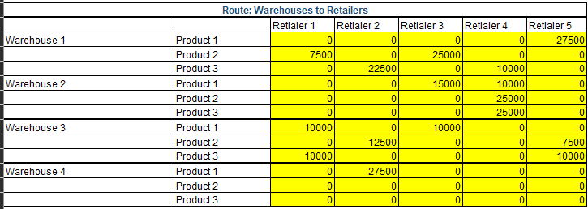

*Figure 9: Product allocated via routes from warehouses to retailers*

In the end, a sensitivity report is generated to identify potential modifications tothe given parameters so as to adjust the decision variables without affecting the entire model (Ravalico et al., 2009). For example, as could be seen in *figure 10*, the transportation cost of product 1 might be lowered by a maximum of 2.55 to activate the direct shipping route from factory 2 to retailer 1. Besides, if all of the adjustment recommended in *figure 10* is applied, the routes to transport product 1 from factory 2 to retailer 2 and retailer 4 will be activated (*figure 11*) without affecting the final cost (*figure 12*). This indicates that sensitivity analysis could be used to support managers’ decision to adjust the variables in the optimization model to better suit their business’s strategies and objectives (Ravalico et al., 2009). For instance, if the company want to eliminate intermediaries, which are the warehouses in the optimized case, to cut the cost of operating them, the managers could make adjustment to activate more direct routes from factories to retailers based on the sensitivity analysis.

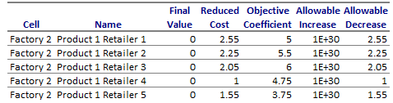

*Figure 10: Sensitivity report for product 1 on the direct route from factories 2 to retailers*

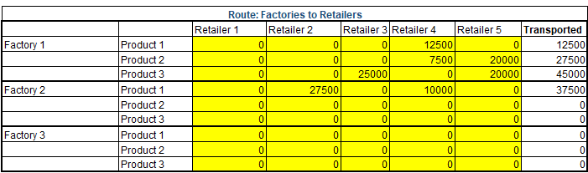

*Figure 11: Changes in route from factory 2 to retailers after applying sensitivity analysis*

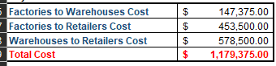

*Figure 12: Total optimized cost after applying sensitivity analysis*

In real-life scenario, rather than four constraints adopted in the optimization model developed in the previous part, there are several constraints that could affect the final optimal result of the model. Therefore, in this final part of the paper, one of the most popular constraints affecting various supply chain and businesses’ operation in recent years will be adopted which is carbon tax constraint. This constraint refers to a tax that is levied on the emission produced during supply chain operation including manufacturing and distributing activities (Ma et al., 2018). Due to the lack of industrial data such as modes of transportation, product categories, transporting distance and so on, the implementation of this constraint in the established model would require data assumption as follow. Firstly, this paper assumes that the company could avoid paying carbon tax if the emission produced through the transportation process is below a certain limit named as carbon emission limit. Secondly, this limit will be assumed and assigned to three main routes in the model. Since the direct route from factories to retailers is less active than the others, the limit will be lower at 400000 emission unit for all three types of products. Meanwhile, all of the routes from factories to warehouse and warehouses to retailers are assigned the carbon emission limit of 900000 emission unit. Moreover, this paper assume that one product transported will account for 10 emission unit. Hence, the carbon tax constraint in this case requires the total emission produced while transporting each type of product in three main routes to be less than or equal to the carbon emission limit.

$$Factories to warehouses: 10*\sum_{f=1}^{3}{\sum_{w=1}^{4}{Xpfw≤900000 (p=1,2,3)}}$$

$$Factories to retailers: 10*\sum_{f=1}^{3}{\sum_{r=1}^{5}{Xpfr≤400000 (p=1,2,3)}}$$

$$Warehouses to retailers : 10*\sum_{w=1}^{4}{\sum_{r=1}^{5}{Xpwr≤900000 (p=1,2,3)}}$$

To explain the equation above, the value of *p=1* is adopted to the first routes from factories to warehouses as an example. In this case, the total quantity of product 1 transported from all three factories to all four warehouses multiply by 10 which equals to the total emission produced by this transportation process need to be less than or equal to the carbon emission limit for these routes which is 900000. After adopting all the values of *p* to all three main routes, the carbon tax constraint is demonstrated in *figure 13*.

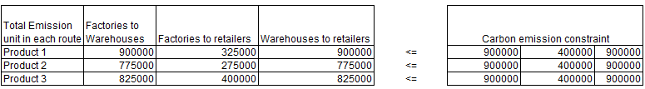

*Figure 13: Carbon tax constraint*

After the constraint is added to Excel solver, the new optimized cost (*figure 14*) is slightly higher comparing to the results generated in the old model (*figure 6*). The reason for the variation in the end results is that the carbon tax constraint restricted the possible number goods that could be carried along the most economical routes. For example, prior to the implementation of the carbon tax constraint, 100000 units of product 1 were allocated to the routes from factories to warehouses (*figure 15*). However, after the constraint is adopted, this amount is restricted to 90000 unit whilst 10000 unit of product 1 reduced from these routes are redistributed to the more costly routes from factories to retailers (*figure 16*). As a consequence, the optimal result is raised as mentioned above. Nevertheless, in practical cases, this increase should be significantly less than the total tax that companies might need to pay if the constraint could not be met (Ma et al., 2018).

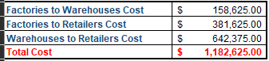

*Figure 14: Optimized result after adopting carbon tax constraint*

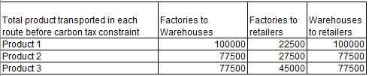

*Figure 15: Product transported before carbon tax constraint*

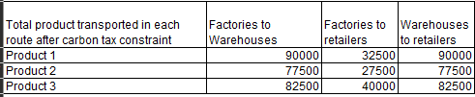

*Figure 16: Figure 15: Product transported after carbon tax constraint*

**References:**

Baller, R., Fontaine, P., Minner, S., & Lai, Z. (2022). Optimizing automotive inbound logistics: A mixed-integer linear programming approach. *Transportation Research. Part E, Logistics and Transportation Review, 163*, 102734. <https://doi.org/10.1016/j.tre.2022.102734>

Bihlmaier, R., Koberstein, A., & Obst, R. (2009). Modeling and optimizing of strategic and tactical production planning in the automotive industry under uncertainty. *OR Spectrum, 31*(2), 311-336. <https://doi.org/10.1007/s00291-008-0147-2> cited by 99

Díaz-Madroñero, M., Peidro, D., & Mula, J. (2014). A fuzzy optimization approach for procurement transport operational planning in an automobile supply chain. *Applied Mathematical Modelling, 38*(23), 5705-5725. <https://doi.org/10.1016/j.apm.2014.04.053>

Gong, L., Zou, B., & Kan, Z. (2019). Modeling and optimization for automobile mixed assembly line in industry 4.0. Journal of Control Science and Engineering, 2019, 1-10. <https://doi.org/10.1155/2019/3105267>

Guo, X., & He, Y. (2022). Mathematical modeling and optimization of platform service supply chains: A literature review. *Mathematics (Basel), 10*(22), 4307. <https://doi.org/10.3390/math10224307>

Hazır, Ö., & Dolgui, A. (2013). Assembly line balancing under uncertainty: Robust optimization models and exact solution method. *Computers & Industrial Engineering, 65*(2), 261-267. <https://doi.org/10.1016/j.cie.2013.03.004>

Ma, X., Ho, W., Ji, P., & Talluri, S. (2018). Coordinated pricing analysis with the carbon tax scheme in a supply chain. *Decision Sciences, 49*(5), 863-900. <https://doi.org/10.1111/deci.12297>

Masoud, S. A., & Mason, S. J. (2016). Integrated cost optimization in a two-stage, automotive supply chain. *Computers & Operations Research, 67*, 1-11. <https://doi.org/10.1016/j.cor.2015.08.012>

Masoud, S., & Mason, S. (2017). Assessing the cost impact of multiple transportation modes to enhance sustainability in an integrated, two stage, automotive supply chain. *Informatics (Basel), 4*(4), 34. <https://doi.org/10.3390/informatics4040034> cited by 4

Otero, S. (2022). The law of supply and demand rules monolignol transport. *The Plant Cell, 34*(5), 1888-1889. <https://doi.org/10.1093/plcell/koac050>

Ravalico, J. K., Maier, H. R., & Dandy, G. C. (2009). Sensitivity analysis for decision-making using the MORE method—A pareto approach. *Reliability Engineering & System Safety, 94*(7), 1229-1237. <https://doi.org/10.1016/j.ress.2009.01.009>

Sadrnia, A., Ismail, N., Zulkifli, N., Ariffin, M. K. A., Nezamabadi-pour, H., & Mirabi, H. (2013). A multiobjective optimization model in automotive supply chain networks. *Mathematical Problems in Engineering, 2013*, 1-10. <https://doi.org/10.1155/2013/823876>

Zhen, L., Zhuge, D., & Lei, J. (2016). Supply chain optimization in context of production flow network. *Journal of Systems Science and Systems Engineering, 25*(3), 351-369. <https://doi.org/10.1007/s11518-016-5304-6>